

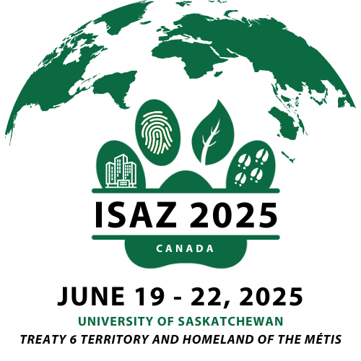

34th International Society for   
Anthrozoology (ISAZ) Conference

Social Media Toolkit

Help Spread the Word About #ISAZ2025!

**Tips:**

* Follow ISAZ on [Facebook](https://www.facebook.com/ISAZOfficial/) & [X/Twitter](https://twitter.com/ISAZOfficial)
* Use our official conference hashtag: **#ISAZ2025**
* Download the graphics below based on the social media platform of your choice – images are already pre-sized for X/Twitter, Facebook, and LinkedIn

*Join the conversation on social media!*

Sample Posts for Attendees:

**Sample Posts for Attendees:**

* I’m counting down the days till the annual International Society for Anthrozoology (ISAZ) conference! Join me June 19-22nd for one of the largest annual gatherings of human-animal interaction researchers in the world. [www.isaz2025.net](http://www.isaz2024.net) #ISAZ2025 @ISAZOfficial

* I’m attending #ISAZ2025 June 19-22nd! Join me in this exciting annual gathering of human-animal interaction researchers worldwide. [www.isaz2025.net](http://www.isaz2024.net) #ISAZ2025 @ISAZOfficial

**Twitter Graphic: Facebook Graphic:**

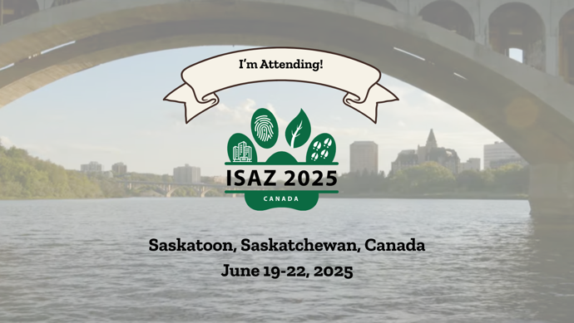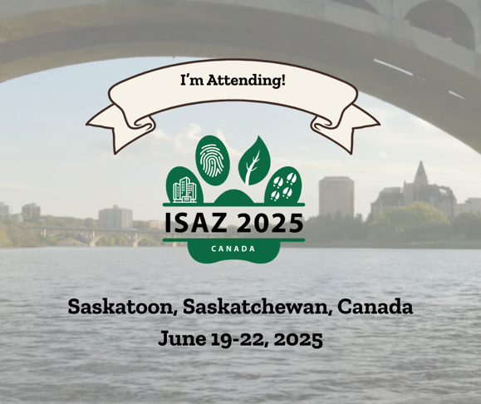

**LinkedIn Graphic:**

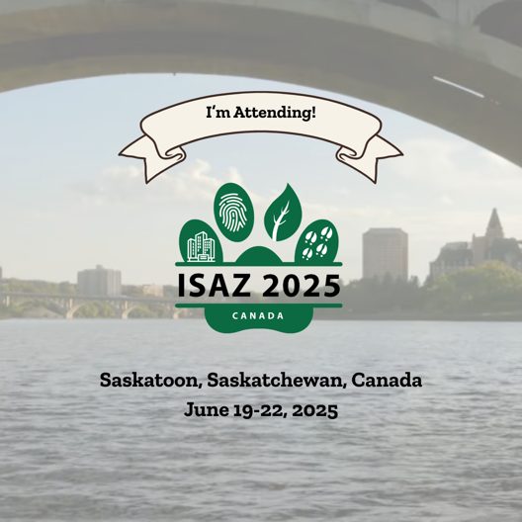

Sample Posts for Presenters:

* I’m presenting on [YOUR TOPIC HERE] at the International Society for Anthroozoology conference on June 19-22nd. Can’t wait to see you there![www.isaz2025.net](http://www.isaz2024.net) #ISAZ2025 @ISAZOfficial

* I’m presenting my research in the [YOUR SYMPOSIUM/SESSION HERE] at the International Society for Anthroozoology conference on June 19-22nd. Can’t wait to see you there![www.isaz2025.net](http://www.isaz2024.net) #ISAZ2025 @ISAZOfficial
* I’m thrilled to be hosting a workshop on [YOUR TOPIC HERE] at the International Society for Anthroozoology conference on June 19-22nd. Can’t wait to see you there![www.isaz2025.net](http://www.isaz2024.net) #ISAZ2025 @ISAZOfficial

**Twitter Graphic: Facebook Graphic:**

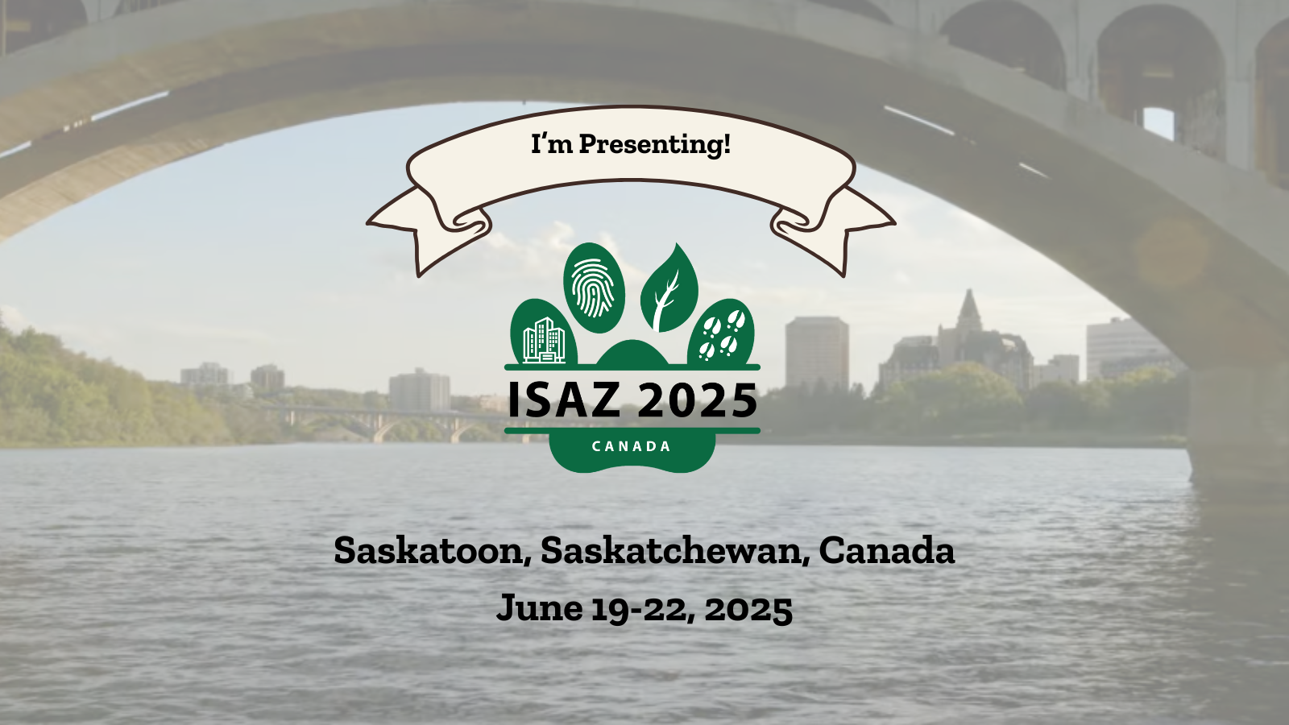 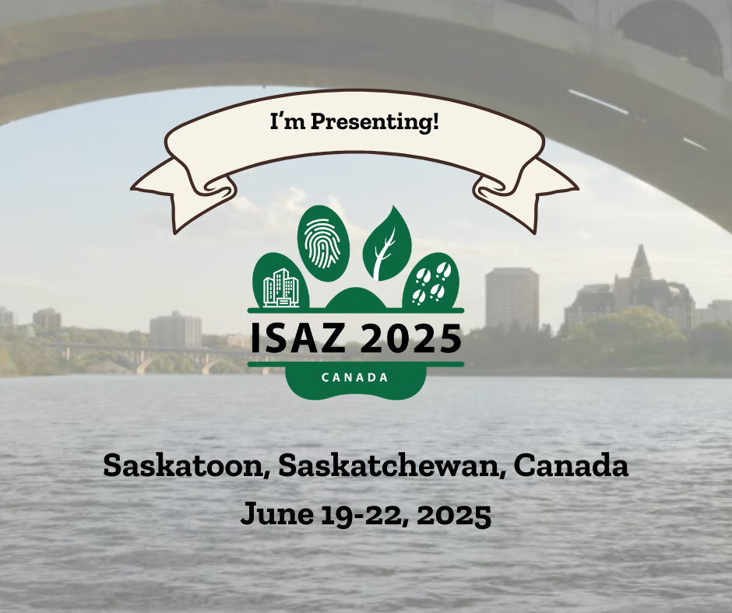

**LinkedIn Graphic:**

